This document walks through the installation of Microsoft Deployment Toolkit. It goes through the process of installing and configuring deployment. It also walks through the configuration of a deployment share, as well as testing the configuration. The second half of the document reviews issues that came up during the lab and troubleshooting steps taken to solve them.

Verify Environment/Network
To start this lab, I verified that my virtual machines could ping each other, IP addresses, and web addresses. After verifying DNS was working properly, I verified that my host machine could also ping IP addresses and web addresses outside of the network. I also pinged my firewall and Windows and Linux subnets from my host machine.

Configure Linux Storage
I edited the Linux VM settings by adding a new hard disk. I made it a 120GB scsi disk. I formatted the disk as a xfs drive. I created a local directory and added the UUID to fstab to mount it. I edited the sshd_config file to allow for root ssh login connections. I was able to login from my host machine using ssh.

Fdisk -l to get a list of disk
Cfdisk /dev/sdb -> GPT drive
Partitioned disk for 120GB
Formatted as mkfs.xfs /dev/sdb1
Mkdir /local
Blkid
Blkid |grep sdb1 -> get UUID
Vim /etc/fstab -> add UUID to fstab
Mount /local/
df -h
vim /etc/ssh/sshd_config -> Allow ssh root login
PermitRootLogin
Systemctl restart sshd
Ssh root@192.168.156.131

Install/ Configure Samba
To install Samba, I created a ssh connection to the Linux machine and ran dnf install samba -y. I ran dnf update -y. I edited global and shared settings in smb.conf. I created username sa-mdt.

Dnf install samba -y -> uses SMB protocol
Dnf update
Vim /etc/samba/smb.conf
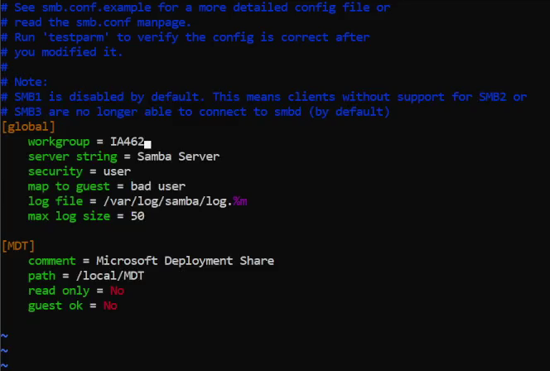

Adduser -M sa-mdt -s /sbin/nologin
Smbpasswd -a sa-mdt -> Enter password new user added
Mkdir /local/MDT

Chown sa-mdt.sa-mdt /local/MDT -R
Systemctl enable –now {smb,nmb}
Systemctl status firewall
Netstat -alnp -> veify port 445

Install MDT Tools
I downloaded the Windows Kits, Windows server 2022 and Windows 10 iso files from the IA462 Class File Repository and extracted the files. I ran the MicrosoftDeploymentToolkit installer. Then I installed the Windows Assessment and Deployment Kit and Preinstallation Environment.

22H@ Workarounds
There is a known bug with MDT in Windows 11. I added the /x86/WinPe_OCs dir to the Windows Preinstallation Environment toolkit folder structure.

MDT Share
I used net use to log into the z: drive from the Linux server. Then, in Deployment Workbench I created a new deployment share.

Net use z: \\192.168.156.131\MDT -> put in samba UN and PW
Specified network share location as \\192.168.156.131\MDT\
Named the share IA462 MDT Deployment Share

Import Operating Systems
MDT does not support esd files. I converted the Windows 10 7 source indexes from eds to wim using dism. I imported Windows 10 and Windows Server 2022 to the MDT share.

Cd W10-21h2
Cd sources
Dir *.wim
Dir *.esd
dism /export-image /SourceImageFile:install.esd /SourceIndex:1 /DestinationImageFile:install.wim /Compress:max /CheckIntegrity

dism /get-imageinfo /imagefile:install.esd -> to see how many images there were

Download VMware Application
Then I ran setup.exe from VMware tools from inside a virtual Windows machine in VMware. Then extracted VMware Tools. I imported them as drivers to the MDT share.

Configure VMware and Deployment Task
I ran exported the Windows .iso file from C:\Program Files (x86)\VMware\VMware Workstation to run in the virtual DVD drive. X86I created a VMware Application in the MDT share using setup.exe /s /v “/qz reboot=r”. Then I created a Task sequence for Windows Servers and Windows 10 operating systems, inserting KMS codes from the internet.
When trying to update the deployment share my second time around, I kept getting an error that the wim file could not be found. I verified that I created the x86 directory correctly. I checked the deployment share properties and noticed that I didn’t uncheck the x86 option, once I unchecked that I was able to update the share successfully.
I ssh into the virtual DVD drive and changed the file
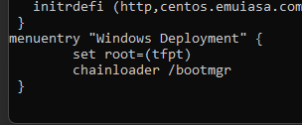
Troubleshooting
When testing my network, I could not ping IP addresses outside of my network. I enabled outgoing ICMP on my Windows firewall but still could not ping external IP addresses. I couldn’t remember my router login, so I had to factory reset my router. After that I was able to ping IP addresses outside of my network.

I kept getting errors when trying to install Samba. “Error: Failed to download metadata for repo 'baseos':” I tried a few different things to correct this. I tried to update dnf by running dnf update -y. I tried to make sure repos were enabled by running grep -rH enabled=1 /etc/yum.repos.d/*. I tried to ensure it was using Linux repository by running sudo dnf config-manager --set-enabled crb.I tried to install subscription manager with yum install subscription-manager and sudo subscription-manager repos --enable codeready-builder-for-rhel-9-$(arch)-rpms.

After going through all of these steps I decided to check PFsense connectivity. I could not ping any of my host from the firewall, and my host could not ping the firewall either. After running ipconfig on my host machine, I seen that VMNET2 was enabled after I previously disabled it. This made me think that resetting my router must have also reset some of the host network settings even though I didn’t have to recreate the virtual networks. I checked the Windows host adaptor, and it changed back to 192.168.156.1. I changed this back to 192.168.156.120 and was able to ping again. I also had to reconfigure the IP address for the Linux host adaptor to be able to contact network from the MGR OS.

When importing Windows Server 2022 operating systems into the deployment workbench, I kept getting an error that it could load the wim file. I tried to erase the iso and associated files and redownload and extract the files again. This didn’t work. I moved the iso file to the MDT drive then extracted it, and I was able to import the operating system.
I got another error that the Deployment share couldn’t load the wim file when I tried updating it. I ended up having a typo in the boot file which I corrected.

When I tried to test the deployment, I could not successfully install the OS through the deployment toolkit. I’m thinking I may have a file path issue as I wasn’t sure if my install files had to be stored in a particular area. I stored them on the Z: directory just because I knew I would be able to access them from any system. Testing is ongoing.

After stepping away for a few days I came back and tried to install the OS using Microsoft Deployment. This time after switching the storage amount to 50GBs instead of 60GBs, I was able to successfully boot to the Windows Deployment Wizard. I then went into the unattended_PE_x64 in the Program Data folder.
After that I tried to update the deployment share, but Deployment Workbench said it was unable to restore the share. I went to Linux MGR and ran the net use command, it then showed the connection was restored.

After my deployment didn’t work as expected, I deleted the whole deployment share when trying to create a new one. I could not find the network file server path.

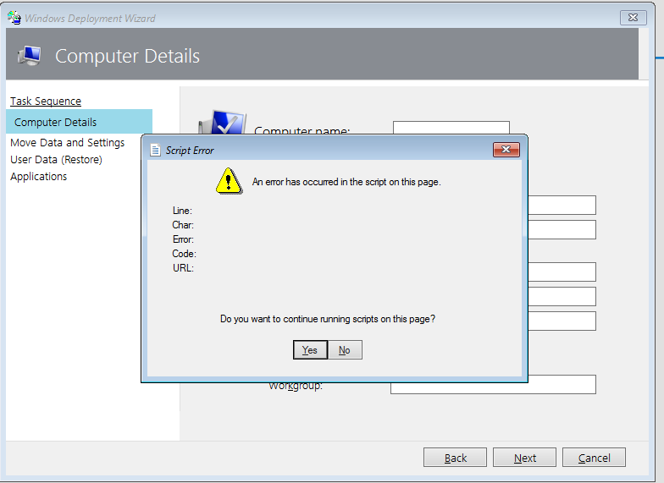

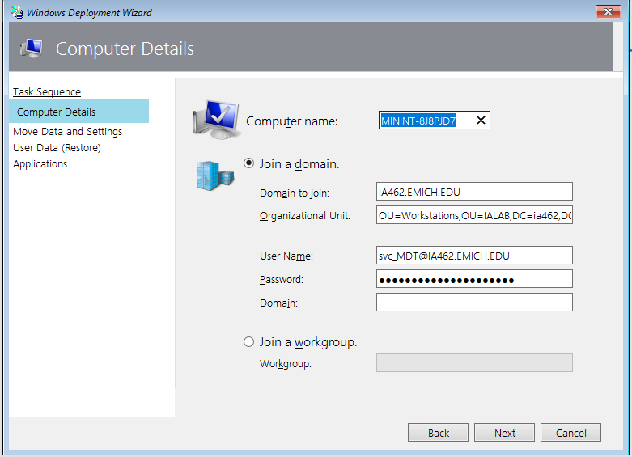

Net use z: /delete to disconnect and reconnect as local host

When creating samba user I couldn’t add the password until I used the command smbpasswd -a sa-mdt

setup.exe /s /v “/qz reboot=r”.
supposed to be
setup.exe /s /v “/qn reboot=r”.

I received the error tftp file not found – that’s because I was changing the file only for the Linux network not the Windows network at it work after updating it on 192.168.156.1

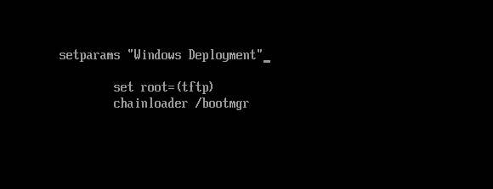

Had to select BIOS boot during install while being signed into localhost through local admin account. I even changed the tftp boot file to that of the LiteTouch iso, thinking MDT would boot then but it did not.
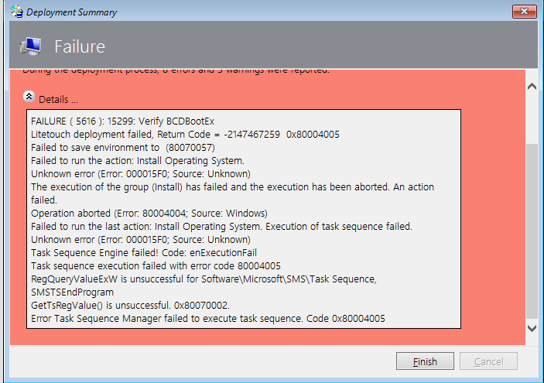

UEFI Sata nvme
